FLCD – Lab 4 – Documentation

Lung Alin-Sebastian, Mărginean Lorena-Simina

Gr. 934/2

Link for github: <https://github.com/IcerOut/FLCD/tree/master/GrammarParsing>

Application Design:

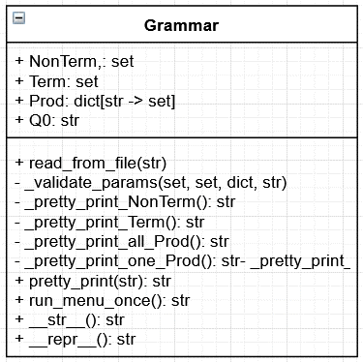

Input File Structure:

* First line contains the set of non-terminals separated by a column in the following structure: Starting symbol, rest of symbols …
* Second line: contains the alphabet
* Third line: set of productions for all the non-terminals

Code structure:

* Menu based application (for showing the user options for displaying the grammar components)
* Read the grammar from file (specify the filename)
* Validate input: check for the production set that all terminals and non-terminals from lhs and rhs to exist in the input list

Grammar class:

* For the terminals and non-terminals we use sets of strings in order to avoid duplicates
* For the productions we use a dictionary with a string as a key and a set as a value
* In the rhs each production is separated by | and each element (terminal/non-terminal) of that production is separated by space.